**Assignment 4**

Q) Write a java program to create a Singly linked list for employee data and perform a. insertion b. deletion c. search d. modify

Input:-

**package** bhushan;

**import** java.util.*;

**public** **class** Main{

node head ;

assignment_4(){

head = **null**;

}

**public** **static** **void** main(String[] args) {

**try** (Scanner sc = **new** Scanner(System.***in***)) {

**int** choice;

assignment_4 obj = **new** assignment_4();

**do**{

System.***out***.println("Enter the op no to be done on the database" );

System.***out***.println("1.Insert the data");

System.***out***.println("2.Delete the data" );

System.***out***.println("3.Search the data");

System.***out***.println("4.Display the data");

System.***out***.println("5.Exit");

choice = sc.nextInt();

**if**(choice == 1)

{

System.***out***.println("Enter the name of the employee");

String d = sc.next();

sc.nextLine();

System.***out***.println("Enter the id of the employee");

**int** i = sc.nextInt();

node n = **new** node(d , i);

obj.insertion(n);

}

**else** **if**(choice == 2)

{

System.***out***.println("Enter the position of data to deleted");

**int** key = sc.nextInt();

obj.deletion(key);

}

**else** **if**(choice == 3)

{

System.***out***.println("Enter the id to search for the name");

**int** i =sc.nextInt();

obj.search(i);

}

**else** **if**(choice == 4)

{

obj.display();

}

}**while**(choice!=5);

}

}

**void** insertion(node new_node)

{

**if**(head == **null**)

{

head = new_node;

}

**else**{

node temp = head;

**while**(temp.next!=**null**)

{

temp = temp.next;

}

temp.next = new_node;

}

}

**void** deletion(**int** key)

{

node temp = head;

node prev = **null**;

**for** (**int** i = 0; i < key -1; i++) {

prev = temp;

temp = temp.next;

}

prev.next = temp.next;

}

String search(**int** id)

{

node temp = head;

**while**(temp!=**null**)

{

**if**(temp.id == id)

{

**return** temp.name;

}

}

**return** "doesnt exists in database";

}

**void** display()

{

node temp = head;

**while** (temp!=**null**) {

System.***out***.println("Name: "+temp.name+"\n"+"ID: "+temp.id);

temp = temp.next;

}

}

}

**class** node{

String name;

**int** id;

node next;

node(String n , **int** i)

{

name = n;

id = i;

next = **null**;

}

}

OUTPUT:-

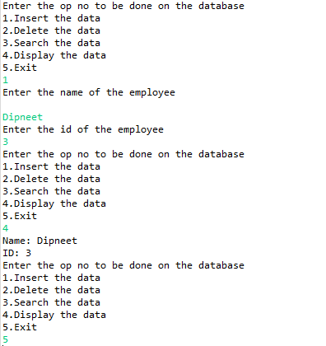

Name:- Yashraj Vijay Aware

PRN no:- 22110167

Roll No.:-224006

Div:-D

Div.:-D1